**How to Access PlayAways Through the Online Library Catalog**

Go to **LIBRARY**

Look for **DESTINY** on the left hand side

CLICK to access the **online library catalog:** <https://crsd.follettdestiny.com>

Select your school

Go to **CATALOG** 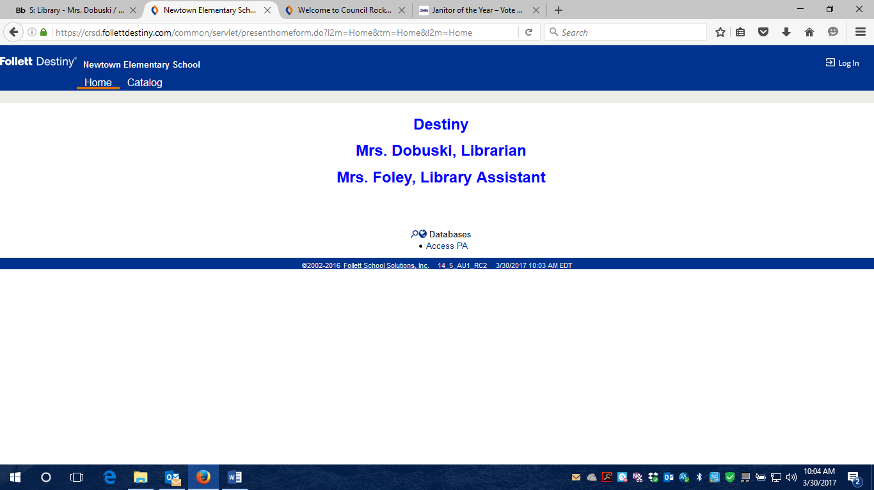

Choose **BASIC** on the top right



Look for **Narrow Your Search to:**

Pull down the location and change to: **Elementary School**

Go to **MATERIAL TYPE:** Choose **SOUND RECORDING (NONMUSICAL)**

Click on **SEARCH**

You will see all of the results and look for the word **PLAYAWAY** to find the audio books

Once you have found a book you like click on **DETAILS**

**In the area that says: There are no local copies of this title. Off-site copies available and select See all…**



It will show the location of the Off-site copies that can be borrowed with the assistance of the library media specialist and the library assistant.

Once you receive your Playaway here is a video of how to use:

<http://my.playaway.com/playaway/how-to-play/>

and here is a HOW TO PLAY document: <http://my.playaway.com/files/Playaway-How_to_Play.pdf>